Event Details Report Access Guide

1. Once the server starts user can access the application http://localhost:4200/

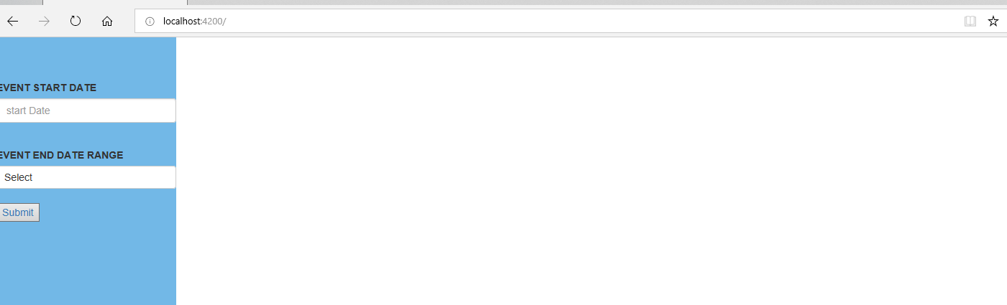

2. In the home page, the user can select an event start date and ranges week, month or Quater to pull the report

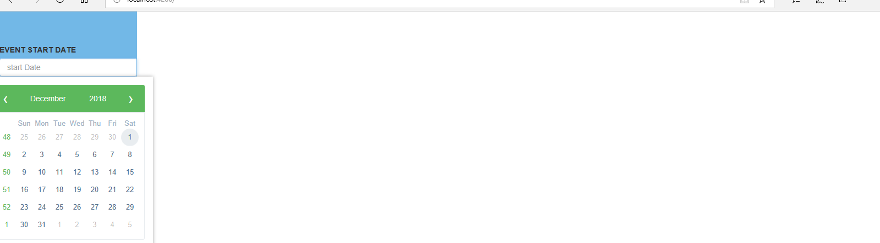

3. Once the report loaded, the user has the following options
a) The user can control how many records to display in the screen
b) The user can filter the records
c) The user can browse next, previous, first and last pages
d) The user is allowed to view event details by hitting the link in Events details columns

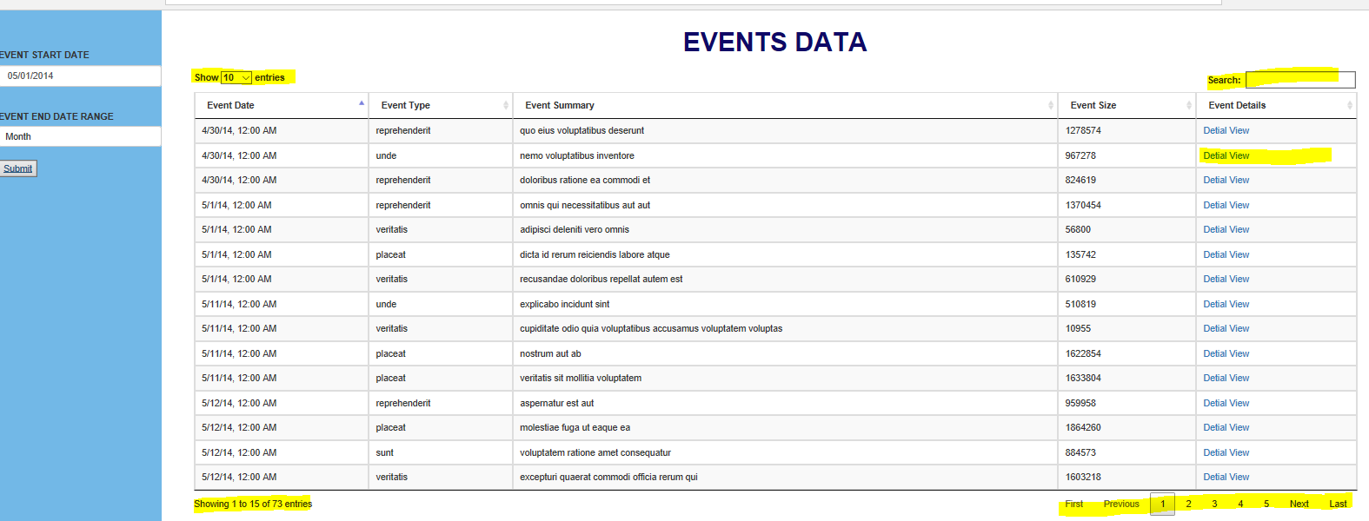
- Event details page

